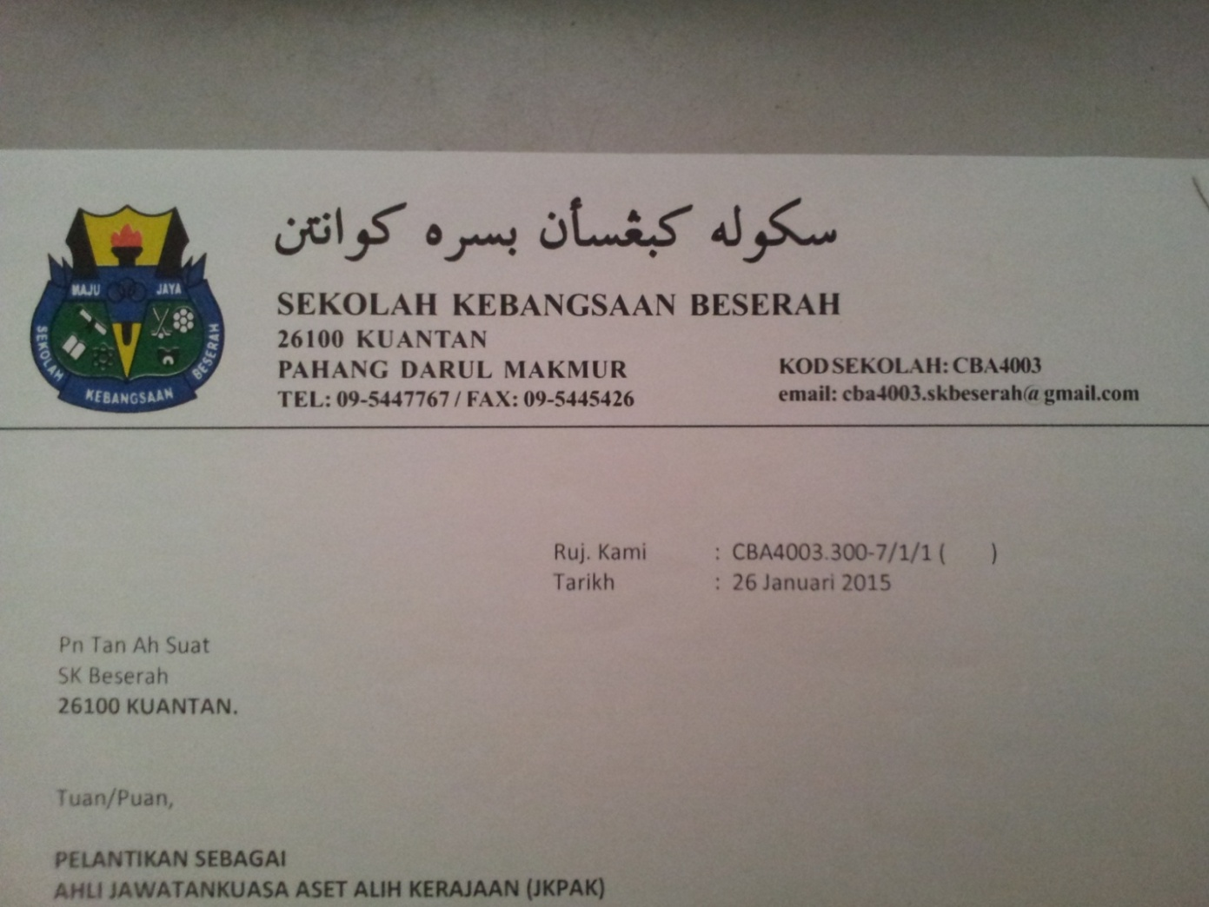

Sekolah Kebangsaan Beserah

English Language Society

Member registration form

Member ID :

*(Student ID)*

Member Name :

Member Class :

Position :

|  |  |  |  |  |  |  |
| --- | --- | --- | --- | --- | --- | --- |
| English Grade | A | B | C | D | E | F |
| Highest English Grade |  |  |  |  |  |  |
| Potential Contestant | **/** | **/** |  |  |  |  |

*Note: - Please tick in the appropriate box for Highest English Grade.*

Guardian :

*(Name)*

Contact Number :

Hereby, I agree to join this society and will obey all of its rules and regulations as an official member.

Signature: _________________ Date: _____________



Sekolah Kebangsaan Beserah

English Language Society

Event form

Event ID :

Event Name :

Event Venue :

Event Date :

Event Level :

Event Chief Advisor :

Event Advisor :

Remarks: _______________________________________________________

_______________________________________________________

_______________________________________________________

_______________________________________________________

Signature: ________________________

*Note: - Please mark * beside the party who signed.*



Sekolah Kebangsaan Beserah

English Language Society

Member Attendance form

|  |  |  |  |  |  |  |  |  |  |  |
| --- | --- | --- | --- | --- | --- | --- | --- | --- | --- | --- |
| No. | Member Name  (Member ID) | Event ID | Attendance | | | | | | | |
|  |  |  |  |  |  |  |  |
| Class | 4  /  2 | 11 /  2 | 18 /  2 | 25 /  2 | 4  /  3 | 11/  3 | 18/  3 | 25  /  3 |
| 1 |  |  |  |  |  |  |  |  |  |  |
| 2 |  |  |  |  |  |  |  |  |  |  |
| 3 |  |  |  |  |  |  |  |  |  |  |
| 4 |  |  |  |  |  |  |  |  |  |  |
| 5 |  |  |  |  |  |  |  |  |  |  |
| 6 |  |  |  |  |  |  |  |  |  |  |
| 7 |  |  |  |  |  |  |  |  |  |  |
| 8 |  |  |  |  |  |  |  |  |  |  |
| 9 |  |  |  |  |  |  |  |  |  |  |
| 10 |  |  |  |  |  |  |  |  |  |  |
| 11 |  |  |  |  |  |  |  |  |  |  |
| 12 |  |  |  |  |  |  |  |  |  |  |
| 13 |  |  |  |  |  |  |  |  |  |  |
| 14 |  |  |  |  |  |  |  |  |  |  |
| 15 |  |  |  |  |  |  |  |  |  |  |
| 16 |  |  |  |  |  |  |  |  |  |  |
| 17 |  |  |  |  |  |  |  |  |  |  |
| 18 |  |  |  |  |  |  |  |  |  |  |
| 19 |  |  |  |  |  |  |  |  |  |  |
| 20 |  |  |  |  |  |  |  |  |  |  |
| Signature of the Advisor In Charge | | |  |  |  |  |  |  |  |  |